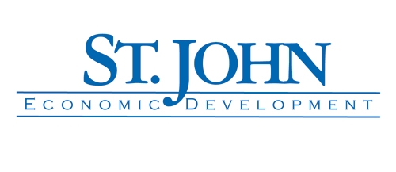 FastTrac® NewVenture™

Early Stage Entrepreneurs and Business Owners who have been operating businesses informally and desire to develop business strategies to grow their business

SEBD Program Certification Workshop

Thursday, February 18th 2016 from 5:30-8:00pm

++++++++++++++++++++++++++++++++++++++++++++++++++++++++++++
Kauffman FastTrac Program Review

10 Sessions

Thursday, March 3rd, 2016 – Thursday, May 12th, 2016
Class Time - 5:30-8:30 PM
Location: St. John the Baptist Business Training Center
(South Central Louisiana Technical College – 181 Regala Park Rd. Reserve, LA)

DATE SESSION
March 3, 2016 1) Exploring Entrepreneurship
March 10, 2016 2) Identifying and Meeting Market Needs
March 17, 2016 3) Setting Financial Goals
March 31, 2016 4) Planning the Product/Service
April 7, 2016 5) Researching and Analyzing the Market
April 14, 2016 6) Reaching the Market
April 21, 2016 7) Building the Organization and Team
April 28, 2016 8) Planning for a Profitable Business
May 5, 2016 9) Monitoring Cash Flow and Seeking Funds
May 12, 2016 10) Implementing Next Steps
TBA Graduation
About FastTrac
FastTrac is a nationally recognized entrepreneurial training program developed by the Kauffman Foundation, a recognized leader in entrepreneurship. Three outcomes of FastTrac are: PERSONAL – to experience a planning process to build confidence and understand business ownership; INTERNAL – to ensure alignment of all aspects of the business; and EXTERNAL – to communicate goals to external parties. Building a business to withstand the test of time requires a unique set of tools. Through FastTrac participants will have the tools to respond to changes that can impact the business and to build an actionable business plan.
The FastTrac Program follows the learning model of “Introduce, Practice, and Apply” which will include facilitated activities & group discussion on each topic; a guest speaker related to the topic; networking; coaching session; and wrap up & action steps. The coaching session allows for individual assistance during each night’s program and between classes.
Each student, besides having their own workbooks, will have access to an online FastTrac Toolkit with lifetime access. Upon completion of the program, follow-up assistance for each student will be available through the Louisiana Small Business Development Center, Greater New Orleans and Bayou Region.
All sessions will be held at St. John the Baptist Business Training Center. Free Parking. FastTrac scholars will receive workbook, handouts, access to on-line tools, as well as refreshments and a light supper each class. The FastTrac Program is open to all certified Small & Emerging Businesses. Certification assistance is available and at Program Overview and Registration.

To Register and for more Information
St. John the Baptist Parish Business Training Center
Phone: 985 479-1247 Email: stjohnbtc@lsbdc.org
Wayne Aucoin, FastTrac Program Manager at 504-982-9160 or waucoin@lsbdc.org
The St. John the Baptist Parish Business Training Center is a partnership of St. John the Baptist Parish Economic Development, Louisiana Economic Development, Louisiana Small Business Development Center, and South Central Louisiana Technical College.
