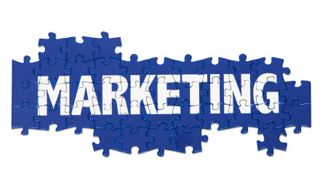
FEDERAL GOVERNMENT MARKETING
AND
IDENTIFYING CONTRACTS

Thursday, March 26, 2015
5:00 P.M. –7:00 PM

UNO Jefferson Center - 3330 N. Causeway Blvd. - Metairie, LA 70002

***FREE AND OPEN TO THE PUBLIC - PRE-REGISTRATION REQUIRED***

Are you interested in accessing new markets, doing business with the Federal Government and identifying contract opportunities?

For more information, call HCCL at 504-885-4262
Email: president@hccl.biz; Website: www.hccl.biz
Or
REGISTER HERE

Topics to be covered include:
- Accessing new markets
- Techniques on how to market to the Federal Government
- The best time to market to the Federal Government
- How to identify contracting opportunities
- Benefits of setting up a Search Agent
- Developing a Marketing Strategy
- Effective use of the Federal Procurement Data System
- Understanding Government Terms

“The U. S. Small Business Administration will not discriminate against anyone based on color, sex, race, religion, creed or ethnic background. Special arrangements for handicapped individuals will be made (with reasonable prior notification) by calling the LSBDC 504-831-3730. Participation does not constitute an expressed or implied endorsement of the participants’ opinions or services.”

