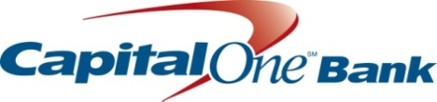

2015 Getting Down to Business Program

New Orleans, LA

Small Business Individual Development Account Program

A matched savings program for qualified small businesses

Participant Information

Name: ____________________________________________________________

Home Address: __________________________________________________

City: __________________________ State: ______ Zip Code: ___________

Home Phone: ____________________________________________________

Personal Cell Phone: ____________________________________________

Personal Email Address: ________________________________________

Business Name: __________________________________________________

Business Address: _______________________________________________

City: ___________________________ State: ______ Zip Code: ___________

Business Phone Number: ________________________________________
Business Email Address and/or Business website: ______________________________________________________________________
____________________________________________

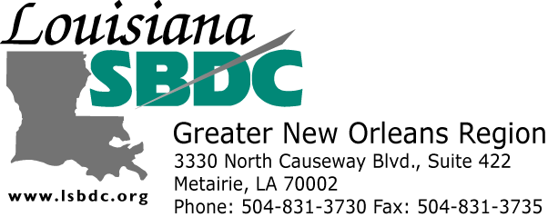

Capital One Public

Application Questions and Requirements

PART A. Please answer the following questions

- Business Duration – To qualify for this program you must have an active established business that has been in existence for at least 12 months. Have you been in business for at least 12 months?

Yes ___ No ___

If yes, for how long? ___________________

- Business Revenue – To qualify for this program your annual business revenues must be less than $1 million. Are your annual business revenues less than $1 million?

Yes ___ No___

- For-Profit Organization – To qualify for this program your business must be an organized for-profit. Is your business an organization for-profit?

Yes ___ No ___

- Organization Type – Are you a sole proprietor, limited liability company, corporation, or partnership? NOTE: If partnership, partners must authorize approval to participate by attaching a simple statement to this application and note the percentages of each partner.

_______________________________________________________________________

- Majority Owner – Are you the majority owner?

Yes ___ No ___

- Current Age – To qualify for this program you must be at least 18 years old. Are you at least 18 years old?

Yes ___ No ___

- Conflict of Interest – Are you or a relative an employee or affiliate of Capital One Bank, the Louisiana Small Business Development Center, or Money Management International?

NOTE: Relatives and employees are ineligible for participation.

Yes ___ No ___

- Citizenship – Are you a U.S. Citizen or legal resident?

Yes ___ No ___

- Savings Account – Opening a savings account at Capital One bank is a prerequisite. Do you object to opening a savings account with Capital One Bank?

Yes ___ No ___

- Commitment – The Getting Down to Business is a 6-8 month commitment. Do you commit to completing the entire 6-8 month program?

Yes ___ No ___

PART B. Please attach the following items with this application package.

- Business Plan – Submit a Business Overview Summary (which may include a business description, business strategy, types of products/services, strengths/weaknesses, future goals, and such that is no more than two (2) pages long.

- DBA Permit – Submit a copy of your DBA (Doing Business As) Permit or Certificate of Formation.

NOTE: If you do not have this permit or certificate, you may attach a brief explanation regarding why it does not apply.

- Financials – Submit a copy of your 2013 or most recent Tax Return, Financial, Profit and Loss (P&L) and Balance Sheet.

PART C. Tell us about your business: (Please attach no more than two (2) pages)

- Program Benefits – What three (3) principle things would you want to get out of this program?

- Versus Others – Why should your small business be selected over others?

Attestation
I hereby attest that the information I have provided in this application, both in answers to stated questions and in attachments, are truthful and accurate.

____________________________________ ____________________
Signature Date

Program Dismissal
Please acknowledge that you can be dismissed from the program and/or be disqualified for the match dollars for any of the following reasons at the sole discretion of the program administrator:
- Excessive tardiness (3 or more times)
- Missing more than one scheduled class
- Missing a class without contacting the program administrator prior to the start of class
- Refusal or inability to open a new Capital One Bank savings account by the date determined by the program administrator
- Any misrepresentation of one’s self or business no matter at what time it is discovered.

____________________________________ ____________________
Signature Date

Please copy this application so that you have a copy for your records before you submit it.

NOTE: if you are called for an interview, please be ready to discuss Part B #1, and Part C.

Submit all pages of this application and all required attachments

by email:
to Mark Boucree at mark.boucree@capitalone.com

or by mail to:

Mark Boucree
Capital One Bank
201 St. Charles Ave
23rd Floor
New Orleans LA 70170

or by fax at:
504.533.3559

If you have questions, please contact:
Lauren Polson
Executive Assistant, Louisiana Small Business Development Center
504.343.9874 or lpolson@lsbdc.org

