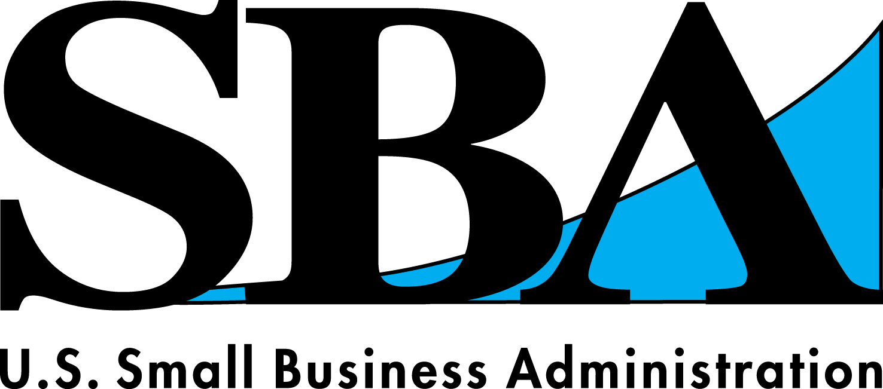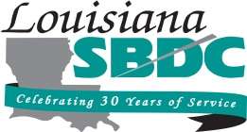

Monday, November 10, 2014
5:00 P.M. – 7:00 P.M.

Where:
UNO Jefferson Center
3330 N. Causeway Blvd.
Metairie, LA 70002

Speaker: Jo Ann Lawrence, Lead Business Opportunity Specialist, SBA

*****FREE AND OPEN TO THE PUBLIC*****

Session Overview:
Small business certifications are like professional certifications. They document a special capability or status that will help you compete in the marketplace. Unlike permits and licenses, you do not need to obtain certifications to legally operate. However, in order to take advantage of business opportunities such as government contracts, you may need to obtain certain certifications. Women business owners should seek to leverage the opportunities available through the federal government to drive revenue growth. This workshop will guide you in doing just that.

Topics to be covered:
- Woman Owned Small Business Federal Government Contract Set-asides
- Final WOSB Ruling and Impact and Advantage
- Eligible NAICS Codes
- WOSB Certification Process
- Identifying Contract Opportunities
- Effectively Responding to Requests for Government Proposal
- Completing Required Registrations

For more information, call HCCL at 504-885-4262
Email: president@hccl.biz; Website: www.hccl.biz

To Register Online:
https://www2.lsbdc.org/workshop.aspx?ekey=1340396

