 | 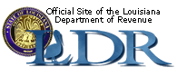 | 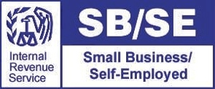

2014 UPDATES FOR CPAs &
TAX PREPARERS

Representatives from the Internal Revenue Service and the Louisiana Department of Revenue will address recent updates affecting how tax preparers and practitioners do business.

2014 Updates for CPAs & Tax Preparers will be presented in a classroom setting.
Questions and comments are encouraged.

Wednesday, October 29, 2014
9am – 12pm (sign-in at 8:30am)
Nicholls State University Bollinger Student Union
Plantation Suite
Brunch Provided
$25 per person

*ONLY RESERVED SEATS ARE GUARANTEED. Please pre-register by Friday, October 24, 2014
- Make checks payable to Loyola University.
- You can mail in payment with registration form or pay at the door.

Register for this event by mailing this form to:

Nicholls State University SBDC: PO Box 2015, Thibodaux, LA 70301
For more information, call (985) 493-2587 or email lsbdc.nic@lsbdc.org or online www.lsbdc.org
Name:
Address:
Phone: |  |  |  | Email:

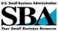


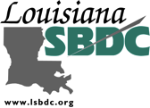



The Louisiana Small Business Development Center is funded in part through a Cooperative Agreement with the U.S. Small Business Administration, Louisiana Economic Development, and Nicholls State University. All SBA programs are extended to the public on a nondiscriminatory basis. Reasonable accommodations for persons with disabilities and limited English proficiency (LEP) will be made if requested at least two weeks in advance.

