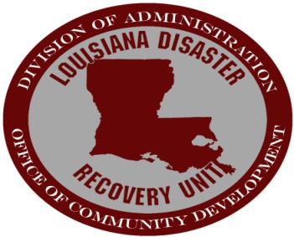

2014 Louisiana Export Training Program
Registration Form

Name: ___________________ ______________________
( First) (Last)

Title: ___________________________________________

Company: ___________________________________________

Business Address: ________________________________________

City: ___________________________________________

State: _______________________ Zip Code: ___________

Phone: (_______) __________________________________

FAX: (_______) __________________________________

Email: ___________________________________________

Web: ___________________________________________

Location (Parish of Business Interest): _____________ Year Established: ____

Description of Product or Services: _________________________________
_______________________________________________________________
_______________________________________________________________

When and Where: All sessions begin at 9:00 am (8:30 am registration). Light lunch provided.

Please check course date(s) of interest:

___ February 11 - Export 201 Louisiana Association of Business and Industry, 3113 Valley Creek Drive,
Baton Rouge, LA 70898-0258
___ February 12 - Export 301 Louisiana Association of Business and Industry, 3113 Valley Creek Drive,
Baton Rouge, LA 70898-0258
___ February 26 - Export 201 Nicholls State University, Century Club Room (underneath stadium stands),
331 Madewood Drive, Thibodaux, Louisiana 70301
___ February 27 - Export 301 Nicholls State University, Century Club Room (underneath stadium stands),
331 Madewood Drive, Thibodaux, Louisiana 70301

For more information on attending the free export training course(s), contact Marisol Canedo at (504) 722-7894. Please submit completed registration form via email to mcanedo50@gmail.com.
Advance registration is required.

