 |  | 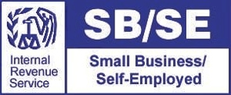

2012 UPDATES FOR CPAs &
TAX PREPARERS

**CERTIFICATES OF ATTENDANCE WILL BE ISSUED**

Representatives from the Internal Revenue Service and the Louisiana Department of Revenue will address recent updates affecting how tax preparers and practitioners do business.

2012 Updates for CPAs & Tax Preparers will be presented in a classroom setting.
Questions and comments are encouraged.

Tuesday, October 23, 2012
9am – 12pm (sign-in at 8:45am)
Nicholls State University
Century Room (under Guidry Stadium)
$25 per person

*ONLY RESERVED SEATS ARE GUARANTEED. Please pre-register by Monday, September 24, 2012

Register for this event by mailing this form to:

Nicholls University College of Business SBDC: PO Box 2015, Thibodaux, LA 70310
For more information, call (985) 493-2587 or email lsbdc.nic@lsbdc.org or online www.lsbdc.org
Name:
Address:
Phone: |  |  |  | Email:

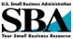


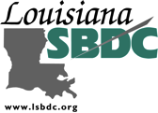
The Louisiana Small Business Development Center is funded in part through a Cooperative Agreement with the U.S. Small Business Administration, Louisiana Economic Development, and Nicholls State University. All SBA programs are extended to the public on a nondiscriminatory basis. Reasonable accommodations for persons with disabilities and limited English proficiency (LEP) will be made if requested at least two weeks in advance.

