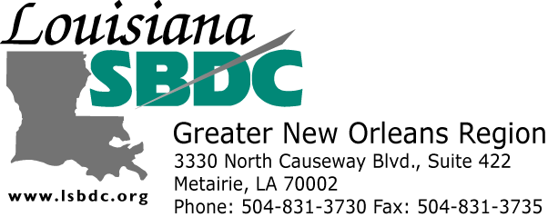 | “Getting Started in  Exporting & Importing”  A four-part series held at the World Trade Center,  Suite 2900, 2 Canal St, New Orleans, LA. 70130
This intensive, four-session training program is designed for individuals wishing to start their own export or import business, as well as for new employees with companies already engaged in international trade.

Upon successful completion of the four-part seminar series, you will receive a Certificate from the LSBDC-GNOR, International Trade Program.

Also includes free counseling in the areas of:
- International Market Research
- International Banking and Finance
- Documentation and Transportation
- International Legal Matters

Part 1  Monday  January 25, 2010  12:30 – 5:00 PM | “Getting Started in Exporting & Importing”  - Introduction  - Keys to Export and Import Success  - Making Contacts: Local and Foreign Assistance  - Channels of Distribution, Drafting Contracts  - Selecting and Preparing Products for Export and Import
Part 2  Wednesday  Janurary 27, 2010  12:30 – 5:00 PM | Pricing, Terms, Quotations, and Customs Entry Procedures  - Export and Import Pricing, INCOTERMS and Quotations  - Export and Import Licenses and Regulations  - Customs Entry Procedures
Part 3  Monday  February 1, 2010  12:30 – 5:00 PM | International Banking, Financing, Transportation, and Documentation  - International Banking & Financing  - Methods of Payment. Letters of Credit  - International Freight Forwarders and Customs Brokers  - International Transportation, Documentation & Logistics
Part 4  Wednesday  February 3, 2010  12:30 – 5:00 PM | International Marketing Plans  - International Market Research  - Preparing Your Export Marketing Plan  - Preparing Your Import Marketing Plan  - The Cultural Environment of International Business

Pre-registration and Pre-payment Encouraged – Limited Seating– Cost includes all sessions and books

For more information, call 504-831-3734 or 504-831-3730
The Louisiana Small Business Development Center (LSBDC) operates in partnership with the US Small Business Administration and the LA Department of Economic Development. The support given by the U.S. Small Business Administration through such funding does not constitute an expressed or implied endorsement of the cosponsors or participants’ opinions, products, or services. The SBDC does not discriminate against anyone based on color, sex, race, religion or ethnic background. Accommodations for handicapped persons will be made upon notification prior to the event by calling SBDC.
“Getting Started in Exporting and Importing”
Dates: January 25, 27, February 1&3, 2010
Location: World Trade Center, Suite 2900, 2 Canal St, New Orleans, LA. 70130

COST: $160.00 for 4-Part Export/Import Seminar Series with Books Included
$80 for individuals who reside or work in Orleans Parish
$120 for WTC and New Orleans Chamber of Commerce members and Full-Time Students
(with proof of enrollment) who do not reside or work in Orleans Parish

Orleans Parish: Yes___; WTC Member: Yes___; Chamber Member: Yes___; Full-Time Student: Yes:___

PLEASE PRINT CLEARLY:
Form of Payment: ___ Cash ___ Money Order ___ Check
___ Credit Card (Complete Card Info on next line)
___ VISA ___ Master Card Credit Card #: ____________________________
Expiration Date: ___________________________

Name as it Appears on the Card: ______________________________________________________________

Signature: ______________________________________  Name: ______________________________________  Company: ______________________________________  Address: ______________________________________  ______________________________________  City: _________________ State: _____ Zip: _______  Phone: __________________Cell: ________________  Fax: ___________________  E-mail: ___________________  Area of Interest: ____ Export ___ Import  Countries of Interest: __________________________  Products/ Services: ___________________________ | Register Now - Limited Seating  Pre-registration and payment encouraged to hold your seat in this program  Make Check or Money Order  Payable To:  Loyola University  And Mail to:  LSBDC Greater New Orleans Region  3330 N. Causeway Blvd. Ste 422  Metairie, LA 70002  Attention: International Trade Program  Or FAX this form with Credit Card Info to:  LSBDC-GNOR at 504-831-3735  Or to pay with credit card over the phone  Call 504-831-3730  with Credit Card information ready

 | The SBDC will not discriminate against anyone based on color, sex, race religion, creed, or ethnic background. Special arrangements for handicapped individuals will be made with reasonable prior notification. | Co-Sponsors:  City of New Orleans  New Orleans Chamber of Commerce  U.S. Customs & Border Protection  U.S. Export Assistance Center  World Trade Center | LSBDC-GNOR  International Trade Program  Information:  Phone: 504-831-3734

